Product Definition
L.Zancani
22 October 2003
Product: Zynap Talent Studio
Release: Optimus

Document version: 0.1 (draft)

Product Definition 1
1. Introduction and Notes 3
2. System Metaphor 4
2.1. Arenas 4
2.2. System and Arena User Roles 4
2.3. Workspaces 4
2.4. Tools 5
2.5. Workflows and Worklets 5
2.6. Artefacts 5
3. Glossary 6
4. The Arenas 7
4.1. System Administration 7
4.2. My Talent 7
4.3. Workflow Definition 8
4.3.1. Actions 8
4.4. Performance Management 10
4.5. Succession Planning 10
4.6. Recruitment and Resourcing 10
4.6.1. User Roles 11
4.6.2. Tools 11
4.6.3. Recruitment Workflow 11
5. The Tools 15
5.1. Organisation Browser 15
5.2. Talent Target Tool 15
5.3. Finder 16
5.4. Scheduler 17
5.5. Profile Wizard 17
5.6. Person Wizard 18
5.7. Position Wizard 18
5.8. Portfolio Browser 18
5.8.1. Content Types and the Profile Browser 19
5.8.2. Browser View 20
5.9. Campaign Manager 20
5.10. Succession Planner 21
6. The Security Model 24
6.1. User Roles 24
7. The Objects 25
7.1. Representing People 25
7.2. Positions 26
7.3. Profiles 26
7.3.1. Composition of Profiles 27

Introduction and Notes

Talent Studio is the working name for the product and will be used throughout.

It is a requirement of the system that the rendering of the presentation layer be highly configurable. This will probably necessitate some form of tool for executing this configuration. This tool is not described in this document.

It is possible that the definition of arenas (see section 2) could be either data driven or (perhaps less ambitious and more achievable) structured as a plug-in mechanism.

It has become obvious that there is a lot of scope for use of right-click context menus in a lot of places in this application (see succession planning, especially). I think it would be very much worth looking into the possibility of having both a browser-based client and a “rich” client application native to Windows. This is pretty much standard practice for enterprise applications with any degree of complexity, and by no means interferes with this being a hosted application.

Open issues are noted in italic, in square brackets, [like this].

System Metaphor

This section aims to describe a consistent metaphor around which Talent Studio will be designed. The framework and vocabulary provided by such a metaphor allow end-users to more quickly and easily understand the system and developers to design and implement coherent software.

The metaphor is loosely built around the idea of an art or crafts studio.

Arenas

The Talent Studio is divided into arenas. Different arenas focus on different areas of the talent management field of activity, for instance Succession Planning, Performance Management etc.

Arenas contain workspaces which in turn contain tools, worklets and artefacts.
Worklets are instances of workflows. Artefacts are the inputs and outputs of tools and processes.

System and Arena User Roles

Each arena has a number of arena user roles associated with it. Depending on the roles they have for that arena, different subsets of functionality are available to users using a particular arena. Arena Roles are assigned by system administrators.

Workspaces

Workspaces are packages of related work items that help users manage their work. They are analogous to Workspaces in Microsoft Visual Studio or Workbooks in Microsoft Excel.

[A sensible representation for workspaces would be a desktop, with artefacts and worklets on it. This clearly wouldn’t work in a browser-based interface…]

Tools

Tools are used to act on artefacts. They often entail a sequence of actions, but are distinct from worklets as the sequence of actions is a user-interface sequence rather than a business sequence.

Workflows and Worklets

Workflows are sequences of business actions defined in the Workflow Definition arena by a workflow designer.

Users may then use workflows, which appear in their workspaces as worklets. A worklet is an instance of a workflow definition.

For instance, a workflow designer might design a workflow for recruitment. This might include steps to approve the job requisition, search for candidates, schedule interviews, classify candidates, respond to candidates, make offers and schedule inductions.

When a recruiter using the recruitment workshop is asked to recruit for a position, they would open a new workspace and create an instance of the recruitment workflow – this is the recruitment worklet that they will now work on.

Artefacts

Artefacts are objects other than processes that exist in a workspace and are currently being worked with by a user. Examples include people, positions, profiles and group containers for all of these.

Artefacts are usually also the inputs and outputs of worklets and tools.

All artefacts have a set of standard fields associated with them (date stamps, “created by” etc.). Additionally, user-defined fields may be added to artefacts during system installation. These fields are free text and can have arbitrary labels.

A special kind of artefact exists that is shared amongst all users that have permission to use it and can neither be created nor deleted by a user. A repository is an example of such an artefact. Examples might include a CV repository or a vacancy repository.

Glossary

This section lists terms used throughout the document that have a specialised or invented meaning.

Term | Definition
Qualities Framework | A set of qualities used globally by an organisation to describe the desired qualities for positions (see “Quality”)
Profile | Textual or Qualities Framework based description of a person or position
Cell | See “Organisational cell”
Organisational cell | General term meaning either a position or a subject person
Position | A position (vacant or filled) in an organisation
Quality | A labelled paragraph defining a specific quality of a person according to an organisation’s qualities framework (see “qualities framework”)
Subject person | A person that is a subject of Talent Studio – i.e. that is being managed through Talent Studio

The Arenas
Arenas could be considered as specialist user interface configurations that group the tools, views and data sources relevant to a particular activity together.

System Administration

Only one role: System Administrator.

- Access rights administration
- User creation and deletion
- System start-up and shutdown
- Diagnostics and usage reporting
- User role assignment
- Succession category definition

My Talent

This is the employee self-service arena. It enables SubjectPersons to update their personal details and material in their profile.

This arena has only one user role: MyTalent::SubjectPerson.

It provides a menu with two options: "update personal data" and "update profile".

Update personal data leads to a form allowing current personal data (e.g. address, next of kin etc) to be updated.

Update profile leads to a wizard that has the following flow:

Add or remove items?
If the user selects remove, the finder tool is started so that the user can search their profile for the material they wish to remove. It then allows them to remove it. [who needs to be notified if data is removed? Should some content types not be removable by a SubjectPerson?]

If the user selects add, a list of content types is presented and the user is invited to select one as the tag for the data that is about to be uploaded, then the user is asked to upload the data

Workflow Definition

This arena provides a tool for creating workflows, which may then be instantiated as worklets by users.

Workflows are composed of steps arranged in a sequence. Each of these steps corresponds to a state of the workflow.

Steps are composed of actions, which can be executed concurrently. Actions can be automatic or manual. Automatic actions are managed and executed by Talent Studio, manual actions require a user to do something and then report to Talent Studio that they have done it.

Actions do not have to be executed in any particular sequence, but all the actions in a step must be complete before the workflow may proceed to the next step.

There are various types of actions, some of which may be executed manually, some automatically and some either manually or automatically.

Transition Actions control transitions from one step to another. There may be more than one transition action in a given step, leading to different subsequent steps. This allows workflows to branch conditionally.

Exactly one step in the workflow may be designated the Start Step, and this is always the first step that is executed.

Actions

Notification Actions
There are six types of notification action, four of which may be executed either manually or automatically:

- NotifyByEmail
- NotifyByLetter
- NotifyByFax
- NotifyBySMS

one of which can only be executed automatically: NotifyImmediate. The NotifyImmediate action causes a notification dialogue to appear on the target user’s desktop if he or she is logged on.[is this really useful?]

and one of which may only be executed manually: NotifyByTelephone

Artefact Creation Actions
There are three types of artefact creation actions. They are:

- CreateArtefactOfType
- CreateArtefactWithTool

CreateArtefactOfType creates an artefact of a specific type. This may occur manually (the user must go and create one and then confirm to the worklet that this has been done) or automatically (the worklet creates one).

CreateArtefactWithTool causes the worklet to automatically launch a specific tool with which the user must then create an artefact.

Categorise Action
The action Categorise is always manual and always requires the user to place multiple artefacts resulting from a previous action into a set of artefact groups that may have lifetimes bound to the worklet or may exist independently of the worklet.

Link Action
There is one type of link action: LinkToWorkflow and it can be automatic or manual.
If it is automatic, it causes the worklet to instantiate another worklet of a different type. An automatic link action is not considered to have completed until the child worklet has reached a WorkflowComplete action (see below).

If it is manual, it requires the user to go and create a new worklet of the correct type, complete its execution, and then report back that this has been done.

If the new worklet type requires an artefact as input and this artefact is currently being managed by the “calling” worklet, a reference to it can be passed with the link action.

Launch Action
The LaunchWorklet action is similar to the LinkToWorkflow action, except that the calling workflow will not wait for completion of the child worklet (the LaunchWorklet action is considered complete as soon as it has spawned the relevant worklet).
Also, the output artefacts of the child worklet cannot be used by the calling worklet.

Transition Action
There is only one transition action: Transition. It can only be automatic.
It transitions the workflow to the next step once a specified set of conditions are satisfied (e.g. all the actions in the workflow are marked complete (either automatically or manually by a user depending on their type)).

A given step may contain more than one transition action, but no two transition actions may have identical conditions associated with them.

Terminal Action
There is only one terminal action: WorkflowComplete. It must be the only action in the final step of the workflow.

User Defined Action
There is one type of user-defined action: UserDefinedAction. It is always manual. It directs the user of the workflow with some text and asks the user to confirm when complete.

Performance Management

Four user roles: Subject, Assessor, Peer and Performance Administrator.

- Questionnaire definition
- Assessment Scheduling
- Questionnaire delivery and completion

Questionnaires

Questionnaires are made up of matched pairs of questions and answers.

Questions are static text and/or graphics.

Each question may be answered using any combination of the following elements:

- Checkbox(es)
- Groups of radio buttons
- Drop-down lists
- Free text entry

Questionnaires are defined using metadata (for example XML files based around a schema for defining questionnaires) describing the questions and the answer mechanism.

This metadata is then used to generate both the representation of the questionnaire to the user for answering (e.g. HTML form) and a storage schema for the answers (e.g. SQL to create database tables).
[An obvious implementation route here is to define an XML schema for questionnaires, then use XSLT to generate HTML for the forms and SQL for the storage].

Succession Planning

The workflows that are associated with the creation, review, approval and maintenance of succession plan objects are associated with this arena.

Recruitment and Resourcing

Recruitment and resourcing (internal recruitment) differ from the other arenas in that they do not have specialised views.

These activities are centred around workflows that should be provided out-of-the-box, but are likely to be changed to suit individual customers as part of the implementation process.

This section therefore describes the tools that will be available in this arena and the out-of-the-box workflows.

These workflows obviously must conform to the material in section 4.3, since they will be defined in the workflow definition arena.

User Roles

- Recruiter
- Hiring Manager
- Authorising Manager

Tools

Recruitment and resourcing both require searching for and comparing various people, position and profiles. These activities may also require the definition of new positions (and therefore profiles).

It follows that the following tools must be available in this arena:

- Finder
- Talent Target
- Profile Wizard
- Person Wizard
- Position Wizard

In addition to this, a specialist tool only available in these arenas is available: the Campaign Manager. This tool allows recruiters to create, track and oversee the execution of an advertising campaign to advertise for a position (see section 5.9).

Recruitment Workflow

Figure 1 outlines a workflow that could be shipped as an example recruitment workflow as a traditional flowchart. Figure 2 shows this same workflow built using actions and named steps as described in section 4.3.

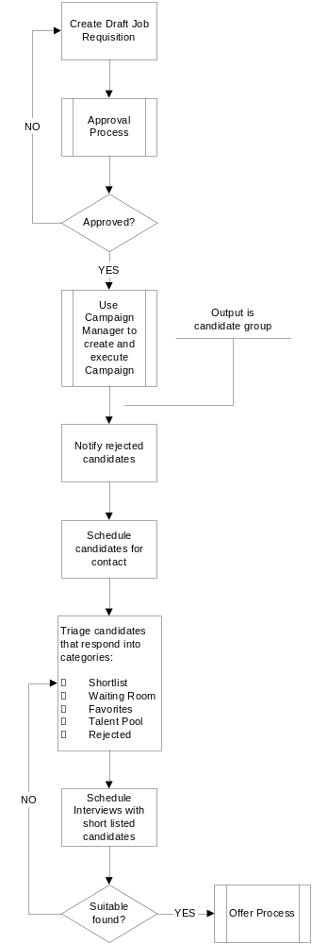
Figure 1 - Sample recruitment workflow

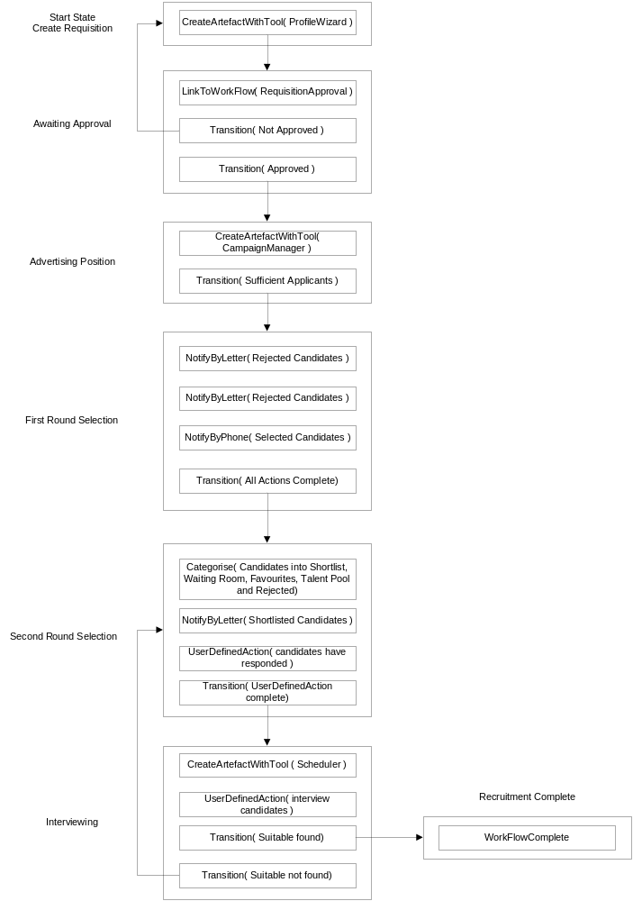
Figure 2 - Recruitment Workflow built using steps and actions

The Tools

This section details tools that exist within the system and are available in various arenas.

Organisation Browser

Launched against an organisation artefact, allows the user to browse that organisation by presenting a tree view of the organisational cells in the organisation.

Talent Target Tool

The talent target tool is a tool for allowing a person to more easily compare:

- sets of people, profiles or position to a given person
- sets of people, profiles or position to a given position
- sets of people, profiles or position to a given profile

The user-actions for this tool are as follows:

- User selects an artefact compatible with the Talent Target Tool (i.e. person, position or profile)
- User launches Talent Target
- User is prompted to label four talent axes [we need a good name for these]
- If the profile of the target artefact was defined using a qualities framework then for each axis the user is prompted to select which qualities correspond to the quadrant
- If the profile of the target artefact was defined using a free text then for each axis the user is prompted to select sections of text that correspond to that axis. If the target artefact was a person, then the profile browser will appear to help select text.
- The system then draws the talent target axes for the target artefact, with each of the axes labelled (see Figure 3)
- The user may then drag additional compatible artefacts into the target. Each of these is plotted using a different colour

Talent targets are outputs of the Talent Target Tool and can be saved for reference or for later editing. This is useful as they represent the result of comparison operations.

Figure 3 shows the output of comparing (say) two people to a position.

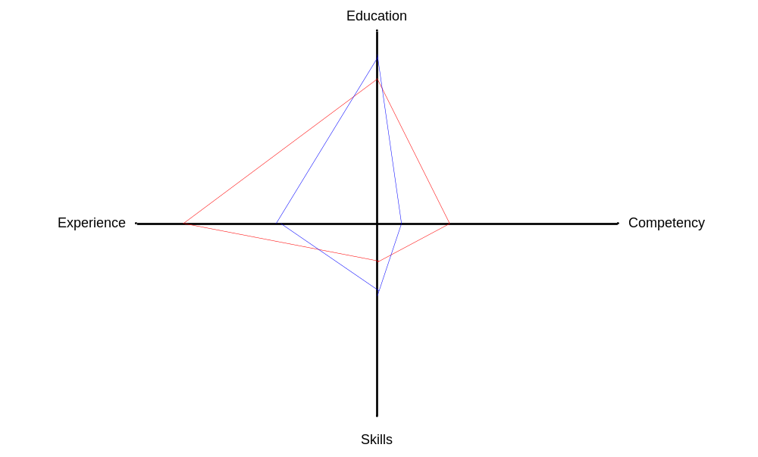
Figure 3 - Example Talent Target

The target is plotted by comparing the axis definitions to the profiles of the plotted artefacts and obtaining a percentage match. 100% is at the intersection of the axes (notice that they are actually demi-axes), 0% is at the extremity. Points plotted nearer the centre represent better matches. Clearly, dragging the same artefact that was used to define the axes onto the target will produce a point at the centre of the diagram.

It is worth noting that it is possible to use this comparison mechanism to produce:

- a scalar result for a comparison between of two profiles to a third according to given criteria (the axis definitions) by measuring the area of the overlap formed by the quadrangles for each profile.

- a scalar result for comparing two profiles to each other by measuring the sum of the percentage matches

Clearly this is not as good a comparison indicator as a human assessment of the diagram, but it could be used to (say) colour organisational cells in a succession plan to give an at-a-glance view of where problems might be.

Finder

The finder tool is used to search repositories or organisations.
Its inputs are either a set of search terms or a profile.
Its outputs are a group of artefacts.

Search terms are specific to a particular repository (this is because different types of repository contain things with different kinds of associated structured data).

Scheduler

The scheduler tool is used by a user to schedule tasks for another user.
Each user in the system has a schedule that shows their current tasks and details of these tasks including due dates.

This functionality is important when workflows require coordination between multiple individuals (e.g. a performance administrator schedules an assessment or a recruiter requests approval for a job requisition).

Profile Wizard

Profiles are artefacts that are used to describe people or positions in Talent Studio.

The Profile Wizard enables the user to create profiles which can be used in a variety of ways in Talent Studio:

- They can be used as search terms when searching anything for people or positions
- People and positions cannot exist independently of profiles. When creating a person or position, users will be prompted to either select an existing profile in their workspace, search for one elsewhere in the system or create one with this tool

The user-actions for creating a profile are as shown in Figure 4.
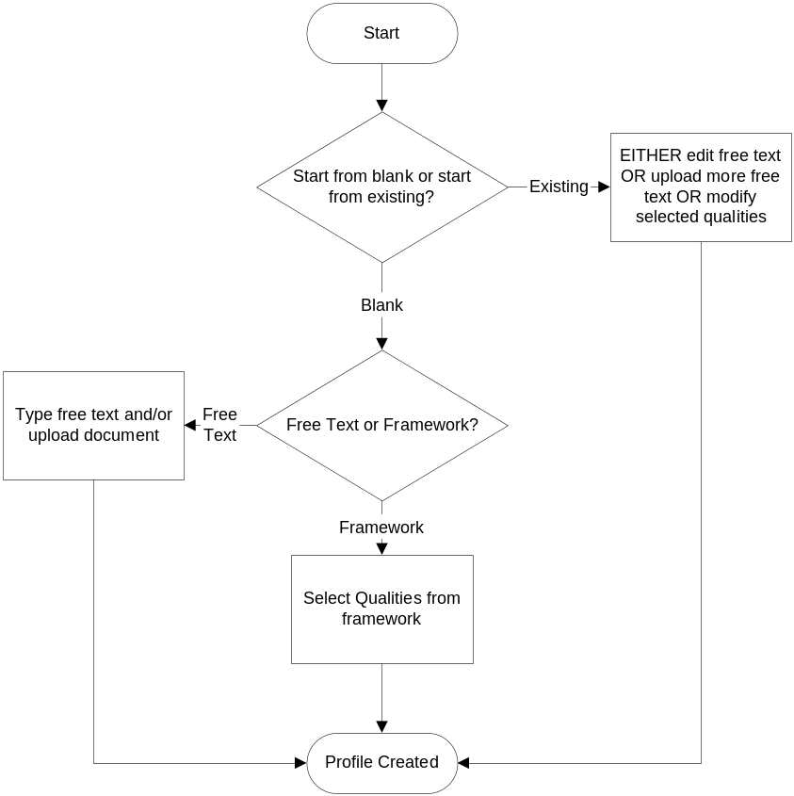
Figure 4 - Profile Creation

Person Wizard

This is a tool for creating SubjectPersons. It either allows a user to mine the structured information relating to a person from a repository or it prompts the user to enter the data.

It then asks the user to select a profile to associate with the position (or launches the profile wizard).

Position Wizard

This is a tool for creating Positions. Prompts user for structured data relating to a position and then asks user to select a profile to associate with the position (or launches the profile wizard).

Portfolio Browser

The portfolio browser is a tool to manage the profiles associated with people (rather than positions).

Profiles for positions will tend to be quite short as they consist of a description of the position. Profiles associated with people on the other hand will be large and will grow over time, since they essentially consist of all the documentation and correspondence that an organization has pertaining to an individual (their CV, all their performance appraisals, correspondence regarding them between managers etc. etc.).

In order to be able to manage this information (for instance when selecting section of text for the Talent Target), a tool must exist to help navigate the profile.

Content Types and the Profile Browser

When material about individuals is imported to their profile, it is tagged by the importing user as belonging to a particular content type. This does not refer to the format of the material, but to the nature of the content. The following content types are defined:

- CVs
CVs for the individual (may be more than one, since CVs are periodically revised or specialized for particular purposes)

- Subject Sourced
Anything the individual has written about themselves (e.g. personal development plans, aspirations, mobility).

- Email
Captured email trains to, from or about the individual

- Written Correspondence
Letters sent to and received from the individual

- Work Products
Any examples of work produced by the individual in the course of their job

- Definitions
Specific educational certifications (e.g. degrees, diplomas etc), competencies and skills that the individual has

- Personal Data
Structured biographical data (name, address, date of birth etc.)

- Training Records
Records of training undertaken by the individual

- Performance assessments and Reviews
The outputs of performance reviews and assessments for the individual

Browser View

The profile browser will present a tree view with root nodes labeled with each content type and leaf nodes for each item of content.

Campaign Manager

This is a tool used in the Recruitment and Resourcing arena to create, execute and track advertising campaigns for vacant positions. Its input is a job requisition and its output is a set of applicants (a group of people).

A campaign is composed of a number of channels. Each channel represents a different delivery medium for the advertisements. Examples of channels might include company intranet, company newsletter, trade publications etc. etc.

The user is asked to name the channels that will make up this campaign.

They are then required to provide:

- advertising copy for each channel (uploaded as files)
- the timeframe for each channel (when the adverts will be placed and for how long)
- a quotation for the cost of the adverts in each channel
- a list of approvers for the campaign

When the user has provided these things for each channel, the campaign manager tool will schedule an approval task for each of the approvers asking them to approve the copy and the cost.

When the approvals arrive, the campaign manager tool will alert the user that they may publish the campaign.

As applicants respond, the user creates a person for each applicant (probably the only profile items these people will have at this stage are CVs and cover letters) and provides the person to the campaign manager.

When the campaign timeframes have all expired, the campaign manager creates a people group and puts all the applicants in the group.

This group is the campaign manager’s output.

Succession Planner

Enables the creation, maintenance and tracking of succession plan objects in the succession planning arena.

The sequence of user-actions for the succession planner tool looks something like this:

- Search an organisation for a position or person by name. Call this organisational cell A.
- View displays the organisation chart fragment showing the cell that A reports to and all the cells directly reporting to A (Figure 5)
- User searches for candidates using the profile associated with either the position or person that is in cell A. User can also use the talent target tool to compare(see section 5.2)
- User classifies candidates according to predefined categories (see section 4.1)
- If candidates are not already direct reports (and therefore shown on view) they are added to the view using dotted-lines to indicate that they are potential successors. Potential successors labelled by category (Figure 6)
- User can move on to create “chained” succession plans (this is to handle the “if B succeeds A, then we now have to build a succession plan for B” situation) by double-clicking a potential successor. System will then display view as in (1) but centred on new subject.

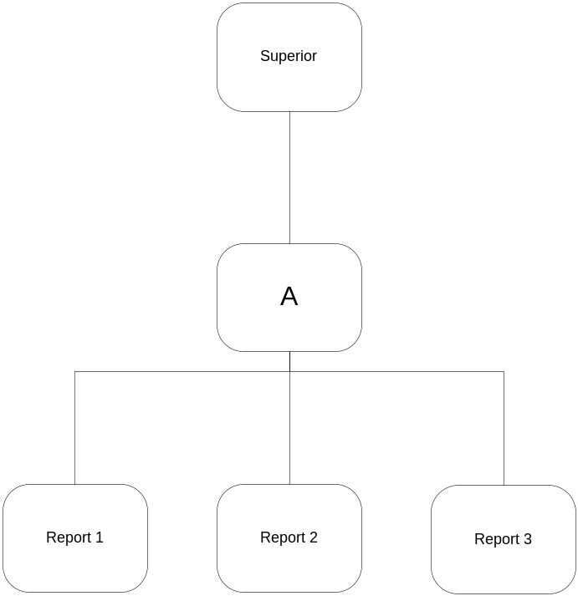
Figure 5 - Initial Succession view; Organisational cell A was the cell originally searched for

Note that in Figure 5, there may be additional superiors show with dotted lines – these are alternate superiors (usually show in org charts using dotted reporting lines). Similarly, alternate reports may be represented.

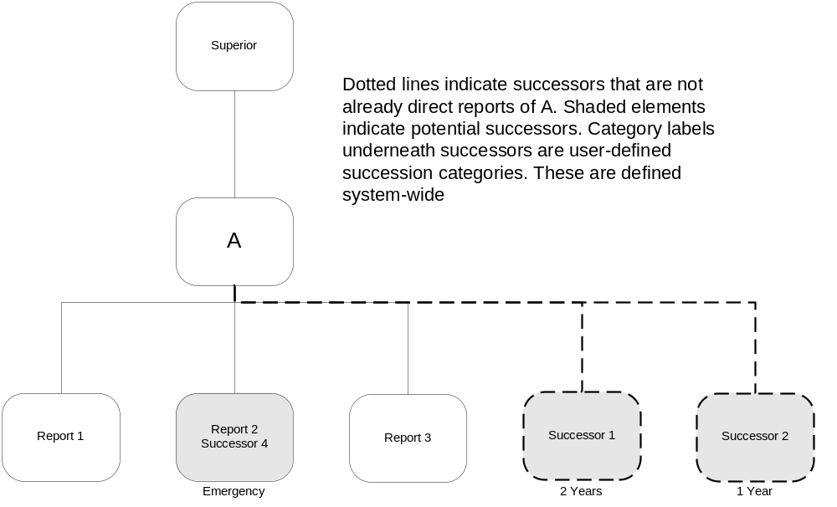
Figure 6 - Succession plan with categorisations

The Security Model

Access control is achieved by means of a combination of three sets of security attributes associated with a user:

- User Roles
- Security Zones
- Assigned Individuals

A user may only view a piece of access-controlled information if they have an appropriate user role AND are assigned to an appropriate security zone OR the information is associated with an individual that is assigned to them.

When information that is to be access-controlled is imported into Talent Studio, it is assigned user role and zone information. Clearly, information can only be imported into a zone or user role by a user that has access permissions matching that role and zone.

User Roles

User Roles are scoped to a particular arena. This is notated in the format <arena name>::<role name>, for example, PerformanceManagement::Reviewer.

User Roles can only be assigned to users by a user who has the role SystemAdministration::RoleAdministrator. When Talent Studio is installed, it has exactly one user already configured with default password and username who has this role.

User roles are arranged in a global tree structure. This structure is used to determine whether an access controlled action may be executed by a user with a given role associated with them.

The Objects

This section aims to describe some of the first-class objects immediately identifiable from the arenas, workflows and tools defined elsewhere in this document.

Note that the class diagrams are not intended to be solution-domain diagrams and therefore do not necessarily imply anything about implementation.

Representing People

There are two distinct and one combined notion of a person within Talent Studio:

- User
- Person represented within it
- Someone who is both a user of the system, and a person represented within it

Figure 7 below shows illustrates class structure for this.

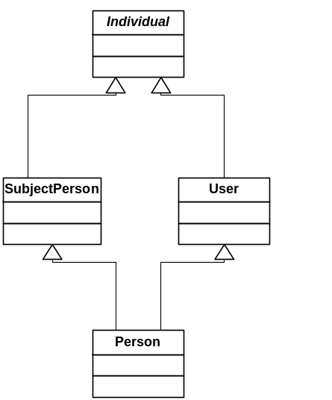
Figure 7 - Suggested class structure for representation of people

The abstract class Individual contains properties common to all individuals, e.g. name, date of birth etc.
SubjectPerson represents an individual who is represented within the system but is not a user of the system, for example an external candidate for employment.
User represents a user of the system. This class would be responsible for authentication info, user names etc.
Person represents someone who is both a user of the system and an individual represented within the system.

Positions

Positions represent vacant or filled positions within an organisation.
Positions can be arranged in tree structures to represent organisations. If a position is filled (i.e. an individual exists that is occupying the position), then a position is associated with the SubjectPerson filling the position.

This is shown in Figure 8 below.

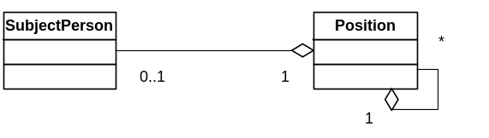
Figure 8 - People and Positions

There are circumstances under which more than one SubjectPerson may need to be associated with a position. For example, during recruitment, it may be desirable to associate all potential candidates with a position. However, this type of association is qualitatively different. An alternative structure might be as show below in Figure 9.

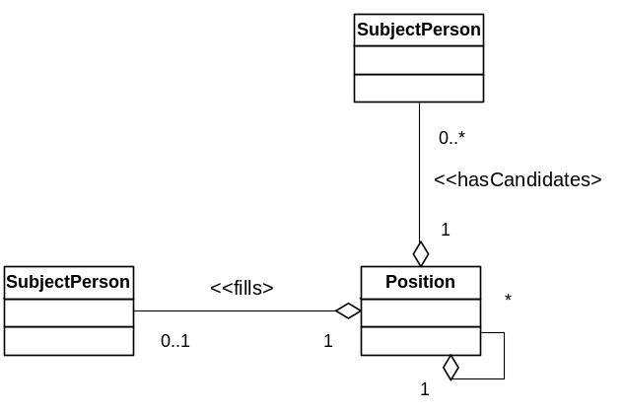
Figure 9 - Candidates for recruitment

Profiles

Profiles are natural language descriptions of people or positions stored as free text.
Profiles are associated both with Positions and with SubjectPersons.
This is illustrated in Figure 10 below.

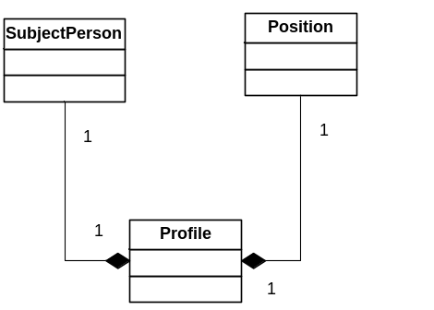
Figure 10 – Profiles

Composition of Profiles

As described in section 5.5, profiles can be created either directly from free text or using a qualities framework. In future there may be other “types” of profiles. Currently we have a structure something like that shown below in Figure 11.

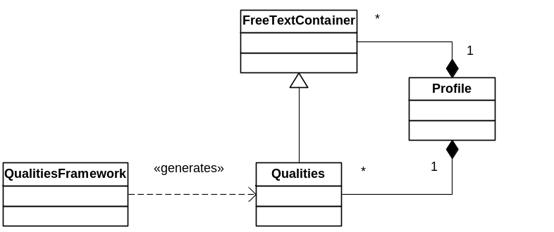
Figure 11 - Composition of profiles

